**Chandigarh University**

**BCA Department**

**Web Page Project Report**

**Problem Statement:-**

**Objective:** Create a Netflix-like user interface (UI) with basic elements such as a navigation bar, a banner section, and a movie grid, similar to what you would see on the Netflix homepage. The design should be responsive, meaning it should adapt to different screen sizes (desktops, tablets, and mobile phones). The UI should also feature a visually appealing layout with smooth hover effects, a clean navigation system, and a user-friendly interface for exploring movies and TV shows.

**Requirements:**

1. Navbar Section:
   * The navbar should have a logo and navigation links, such as:
     + Home
     + TV Shows
     + Movies
     + Latest
     + My List
   * The navbar should remain at the top of the page as the user scrolls (sticky navbar).
   * The logo should be prominent, and the links should be styled to stand out with a hover effect.
2. Banner Section:
   * The banner should feature a full-screen background image (e.g., a popular Netflix promotional image).
   * Overlay content should include:
     + A headline like "Popular on Netmovis"
     + A brief description of the service, e.g., "Watch your favorite shows and movies anytime, anywhere."
     + A prominent "Watch Now" button, styled to encourage interaction.
   * The banner section should have an aesthetically pleasing color overlay to ensure readability of the text.
3. Movie Grid Section:
   * A grid layout should display images of popular movies or TV shows.
   * The grid should be responsive, adjusting the number of columns based on the screen width.
   * Each movie or show image should have a hover effect that slightly enlarges the image to indicate interactivity.
4. Responsiveness:
   * The layout should adjust automatically based on screen size:
     + On large screens (desktops), the banner should take up a significant portion of the screen.
     + On smaller screens (tablets, mobile devices), the movie grid should adapt and display fewer columns.
   * Text, images, and buttons should scale appropriately, ensuring good readability and usability on different devices.
5. Styling and Branding:
   * The overall color scheme should be similar to Netflix's red and black theme, with:
     + A dark background (for the body and some sections).
     + Red accents for important UI elements like the logo, buttons, and headings.
   * The fonts should be modern and easy to read, with a combination of fonts like Montserrat and Nunito for good contrast and legibility.
6. Interactivity:
   * The design should feel interactive with smooth hover transitions (e.g., movie images zooming in on hover).
   * Buttons should have hover effects that change their appearance when the user hovers over them.

Key Challenges:

* Implementing a responsive design that works across a variety of devices.
* Creating a sticky navbar that remains visible while scrolling.
* Styling elements like buttons and images with hover effects to create a dynamic user experience.
* Ensuring cross-browser compatibility and optimizing the layout for different screen sizes.

**HTML CODE:**

<!DOCTYPE html>

<html lang="en">

<head>

  <meta charset="UTF-8">

  <meta name="viewport" content="width=device-width, initial-scale=1">

  <title>Netflix Clone</title>

  <link rel="stylesheet" href="style.css">

</head>

<body>

  <header class="navbar">

    <div class="logo">NETMOVIeS</div>

    <nav>

      <ul class="nav-links">

        <li><a href="#">Home</a></li>

        <li><a href="#">TV Shows</a></li>

        <li><a href="#">Movies</a></li>

        <li><a href="#">Latest</a></li>

        <li><a href="#">My List</a></li>

      </ul>

    </nav>

  </header>

  <section class="banner">

    <div class="banner-content">

      <h1>Popular on NetmoviEs</h1>

      <p>Watch your favorite shows and movies anytime, anywhere.</p>

      <button>Watch Now</button>

    </div>

  </section>

  <section class="movies">

    <h2>Trending Now</h2>

    <div class="movie-grid">

      <img src="Money heist.jpg" alt="Money Heist">

      <img src="Stranger Things.jpg" alt="Stranger Things">

      <img src="Kota factory.jpg" alt="Kota Factory">

      <img src="Squid games.jpg" alt="Squid games">

      <img src="Friends.jpg" alt="Friends">

      <img src="Wednesday.jpg" alt="Wednesday">

      <img src="heera mandi.jpeg" alt="heera mandi">

      <img src="harry potter.webp" alt="harry potter">

    </div>

  </section>

</body>

</html>

**CSS CODE:**

@import url('https://fonts.googleapis.com/css2?family=Montserrat:ital,wght@0,100..900;1,100..900&family=Nunito:ital,wght@0,200..1000;1,200..1000&display=swap');

@import url('https://fonts.googleapis.com/css2?family=Montserrat:ital,wght@0,100..900;1,100..900&family=Nunito:ital,wght@0,200..1000;1,200..1000&display=swap');

@import url('https://fonts.googleapis.com/css2?family=Montserrat:ital,wght@0,100..900;1,100..900&family=Nunito:ital,wght@0,200..1000;1,200..1000&display=swap');

body{

    font-family: nunito, sans-serif;

}

* {

    margin: 0;

    padding: 0;

    box-sizing: border-box;

  }

  body {

    background-color: #222222;

    color: #fff;

    font-family: Arial, sans-serif;

  }

  .navbar {

    display: flex;

    justify-content: space-between;

    padding: 20px;

    background-color: #1c0000ad;

    align-items: center;

  }

  .logo {

    font-size: 24px;

    font-weight: bold;

    color: #ff0000;

  }

  .nav-links {

    list-style: none;

    display: flex;

    gap: 20px;

  }

  .nav-links a {

    color: #fff;

    text-decoration: none;

    font-weight: 500;

  }

  .banner {

    background: url('https://assets.nflxext.com/ffe/siteui/vlv3/71cefa4b-b77d-4c5a-bff2-3dc4ed13458a/7f3d112e-6a8a-4978-a0b5-08bb124e0d5d/US-en-20240311-popsignuptwoweeks-perspective_alpha_website_small.jpg') center/cover no-repeat;

    height: 40vh;

    display: flex;

    align-items: center;

    justify-content: center;

    text-align: center;

  }

  .banner-content {

    background-color: rgba(0, 0, 0, 0.6);

    padding: 40px;

    border-radius: 10px;

  }

  .banner-content h1 {

    font-size: 3rem;

    margin-bottom: 20px;

    color: #ff0000;

  }

  .banner-content p {

    font-size: 1.2rem;

    margin-bottom: 20px;

  }

  .banner-content button {

    padding: 10px 20px;

    font-size: 1rem;

    background-color: #ff0000;

    color: white;

    border: none;

    cursor: pointer;

    border-radius: 5px;

  }

  .movies {

    padding: 20px;

  }

.movies h2 {

    margin-bottom: 15px;

    font-size: 1.5rem;

  }

  .movie-grid {

    display: grid;

    grid-template-columns: repeat(auto-fit, minmax(150px, 1fr));

    gap: 15px;

  }

  .movie-grid img {

    width: 100%;

    border-radius: 8px;

    transition: transform 0.3s;

  }

  .movie-grid img:hover {

    transform: scale(1.05);

  }

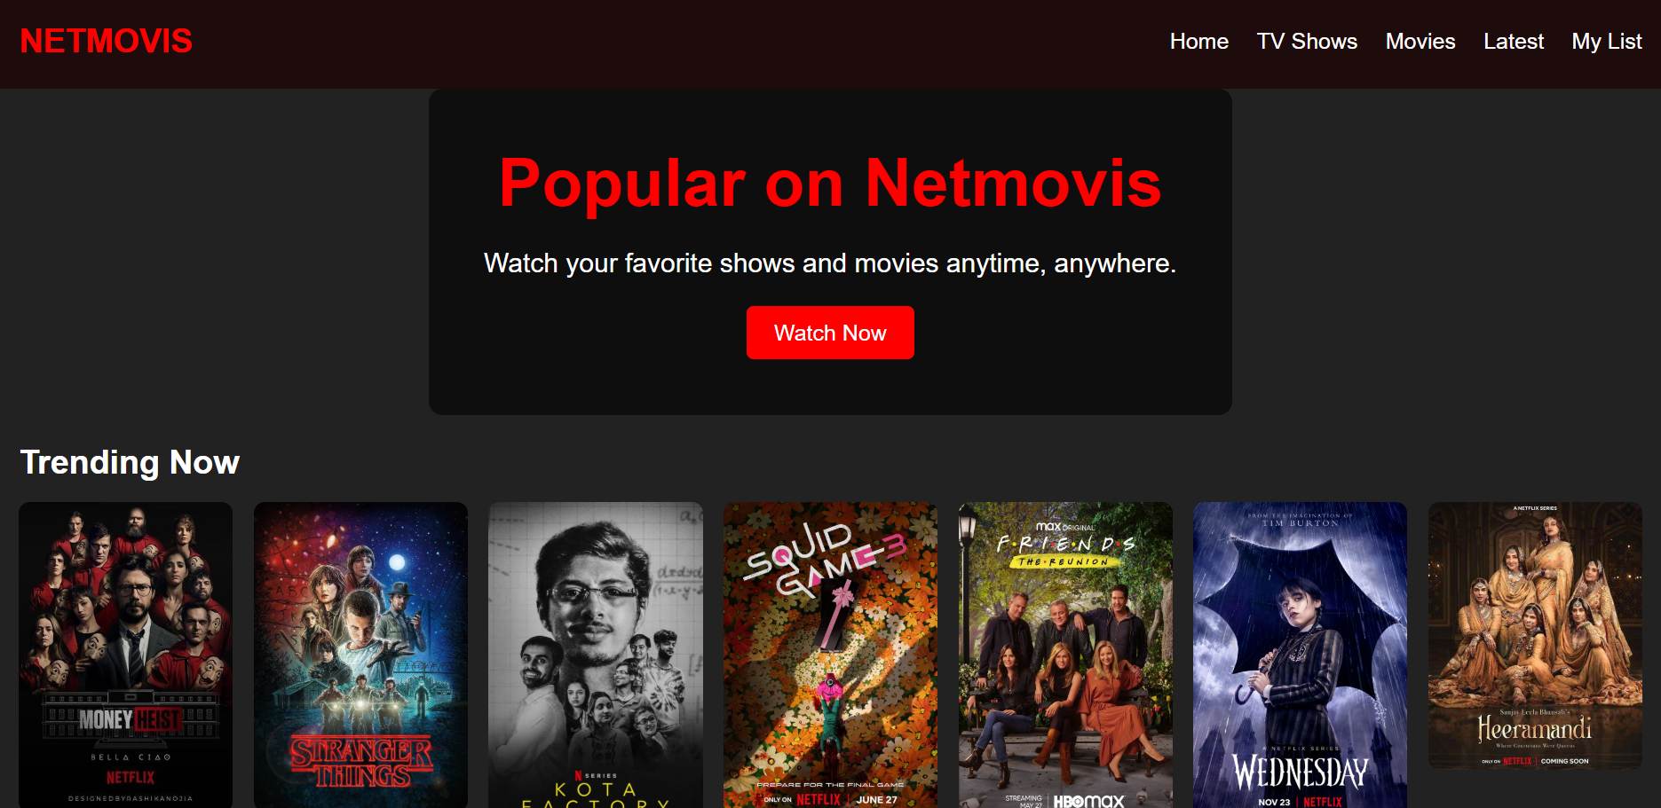

Submitted By:Taniya Thakur

Submitted To: Mrs.Palwinder kaur

Section:24bca-3(A)

UID:24bca10155

Subject:Web Designing